Task 4
Develop the Use Case Model:
- Identify all system actors.
- Create one complete Use Case Diagram.
- Fully document three use cases using the use case template. [3 marks]

Task 4: Use Case Model
1. System Actors
- Student: Browses activities, registers, cancels registrations, scans QR codes for attendance, and views their activity history/transcript.
- Activity Organizer: Creates and updates activities, manages participant capacity, records attendance manually if needed, and issues certificates.
- Student Affairs: Reviews and approves proposed activities, oversees university-wide participation statistics, and validates student activity transcripts prior to graduation.
- Notification System: Automated secondary system that sends push notifications and emails for confirmations, waitlist status updates, and event reminders.

2. Use Case Diagram Overview
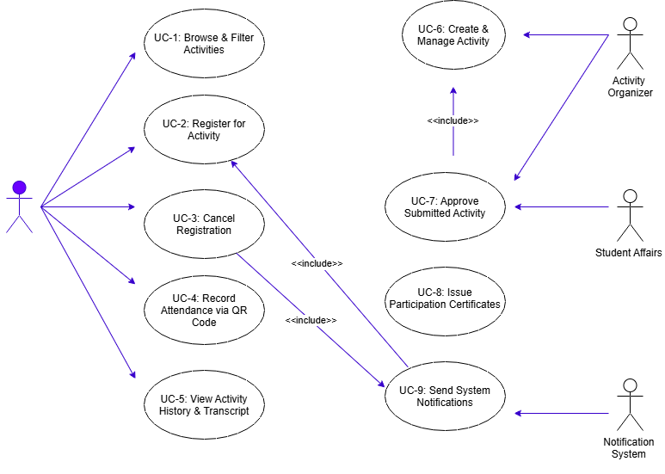

- UC-1: Browse & Filter Activities
- UC-2: Register for Activity
- UC-3: Cancel Registration
- UC-4: Record Attendance via QR Code
- UC-5: View Activity History & Transcript
- UC-6: Create & Manage Activity
- UC-7: Approve Submitted Activity
- UC-8: Issue Participation Certificates
- UC-9: Send System Notifications
3. Detailed Use Case Documentation
Use Case 1: Register for Activity
Field | Details
Use Case Name | Register for Activity
Actor(s) | Student
Description | Allows a student to reserve a seat in an available activity.
Pre-conditions | Student is logged in and the activity status is active/open.
Post-conditions | Student registration status is saved, available seat count decreases by 1, and confirmation is sent.
Main Success Scenario | 1. Student selects a specific activity from the list.  2. System displays activity details and seat availability.  3. Student clicks "Register".  4. System verifies eligibility and checks seat availability.  5. System confirms registration and updates available seat capacity.  6. System triggers a confirmation notification to the student.
Alternative Flows | A1: Activity Full: System prompts the student to join the Waitlist.  A2: Registration Closed: System displays an error message stating the deadline has passed.

Use Case 2: Create & Manage Activity
Field | Details
Use Case Name | Create & Manage Activity
Actor(s) | Activity Organizer
Description | Allows organizers to create a new activity and set its parameters.
Pre-conditions | Organizer is authenticated in the system.
Post-conditions | Activity is created with status "Pending Approval".
Main Success Scenario | 1. Organizer navigates to "Create Activity" page.  2. Organizer inputs title, category, date, capacity, location, and attendance method.  3. Organizer submits the form.  4. System validates inputs and saves the activity under "Pending Approval".  5. System notifies Student Affairs for review.
Alternative Flows | A1: Incomplete Information: System highlights missing required fields and prompts correction.

Use Case 3: Record Attendance via QR Code
Field | Details
Use Case Name | Record Attendance via QR Code
Actor(s) | Student, Activity Organizer
Description | Electronically records student attendance at the event venue.
Pre-conditions | Event is currently active and student has a confirmed registration.
Post-conditions | Attendance is marked as "Attended", and participation hours are added to the transcript.
Main Success Scenario | 1. Organizer displays the session's QR Code.  2. Student scans the QR Code using the SAMS mobile application.  3. System validates time, location, and student registration status.  4. System records student status as "Attended".  5. System updates student's activity record and transcript automatically.
Alternative Flows | A1: Student Not Registered: System displays "Registration Not Found" and prevents recording attendance.

